EXTRA MILE AWARD DOCUMENT
Instructions to create and print an Extra Mile Certificate – 01/11/2024

The WORD document on the next page can be edited to insert the Name of the Extra Mile Award recipient and the Date of the award.
Just a Note: WORD may require you to click on a button to make the document editable …
The picture below shows the text boxes that will open when you click on either “Name” or “Date” .. just edit the content and then save and print the page (print in color – page 2 only) for signature and eventual presentation to the recipient(s). If necessary the text box(es) can be lengthened by dragging the left and/or right box buttons an appropriate distance…
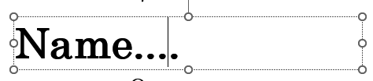
Don’t forget to let the Federation webmaster know about the award so the name(s) can be added to the Federation website!!

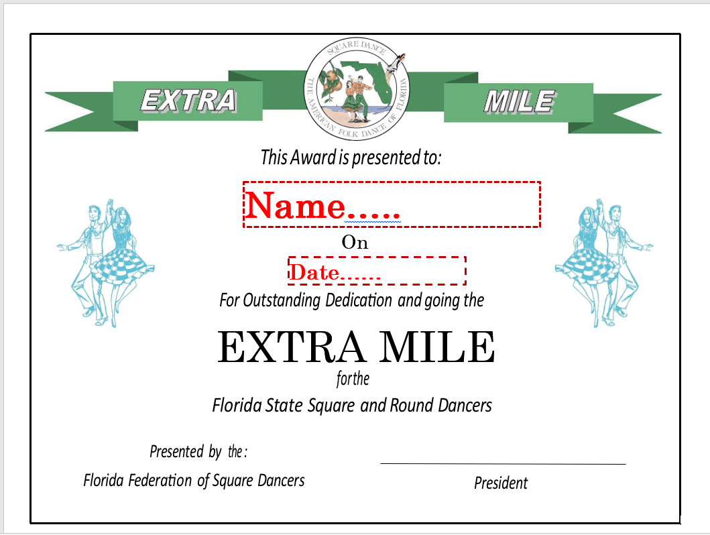
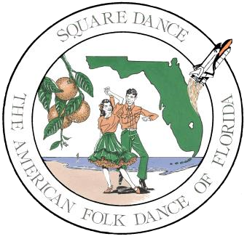

This Award is presented to:

Name....

On

Date……

For Outstanding Dedication and going the

EXTRA MILE

for the

Florida State
Square and Round Dancers

President

Presented by

the
:

Florida Federation of Square Dancers

